[CA LISA Service Virtualization](http://www.ca.com/us/service-virtualization.aspx" \t "_blank)

Captures and simulates the behavior, data and performance characteristics of complete composite application environments, making them available for development and test teams throughout the software lifecycle, for faster time-to-market with quality software functionality at lower infrastructure cost.

Service Virtualization (or SV) automates the creation of complete software-based environments that simulate observed behaviors, stateful transactions and performance scenarios, not just piecemeal responders or stubs. These Virtual Service Environments (or VSEs) are available 24/7, on demand, and require minimal setup time and overhead. [CA LISA's](http://www.ca.com/us/products/detail/CA-LISA.aspx) virtual services provide a solution for IT assets such as mainframes or shared services that have proven resistant to hardware virtualization approaches.

Service Virtualization can be leveraged when live systems are not available due to project scheduling or access concerns. In cases where components have not been built yet, virtual environments can rapidly model and simulate the components from definitions for testing purposes. VSEs can be rapidly created and customized, and deployed on-premise or in Private and Public cloud-based labs, enabling faster parallel development across interdependent teams.

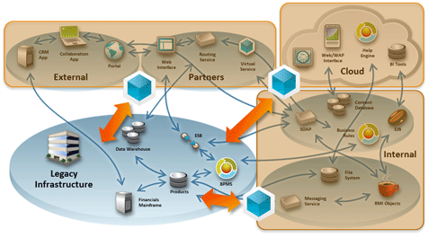  
*Service Virtualization simulates the behavior, data and performance profiles of system constraints and unavailable services in the development and test environment.*

Benefits of Service Virtualization with CA LISA Solutions:

* Faster Time-to-Market: By eliminating constraints on every phase of the SDLC, Service Virtualization can accelerate delivery time for software projects by 25-50%.
* Lower Infrastructure Costs: Avoid and eliminate millions of dollars in costs for lab infrastructure, test harnesses, responders and mock-ups, including hardware, software licenses, service access fees, and configuration costs.
* Enable Parallel Development: Allow Agile development and test teams to "decouple" from the complex application architecture to work in parallel, without conflicts over labs and data.
* Shift Quality Left: All of these capabilities allow LISA users to ensure quality at a component level, much earlier in the SDLC, so that far fewer defects and performance issues escape into QA and Production environments, where they are the costliest to repair.

CA LISA Service Virtualization delivers a powerful solution to the problem of system dependency constraints, ensuring that innovative IT functionality is delivered faster, with higher quality and performance.

**VERSIONS:**

**Latest is 8.0**

**CA LISA 7.5.2 older one**